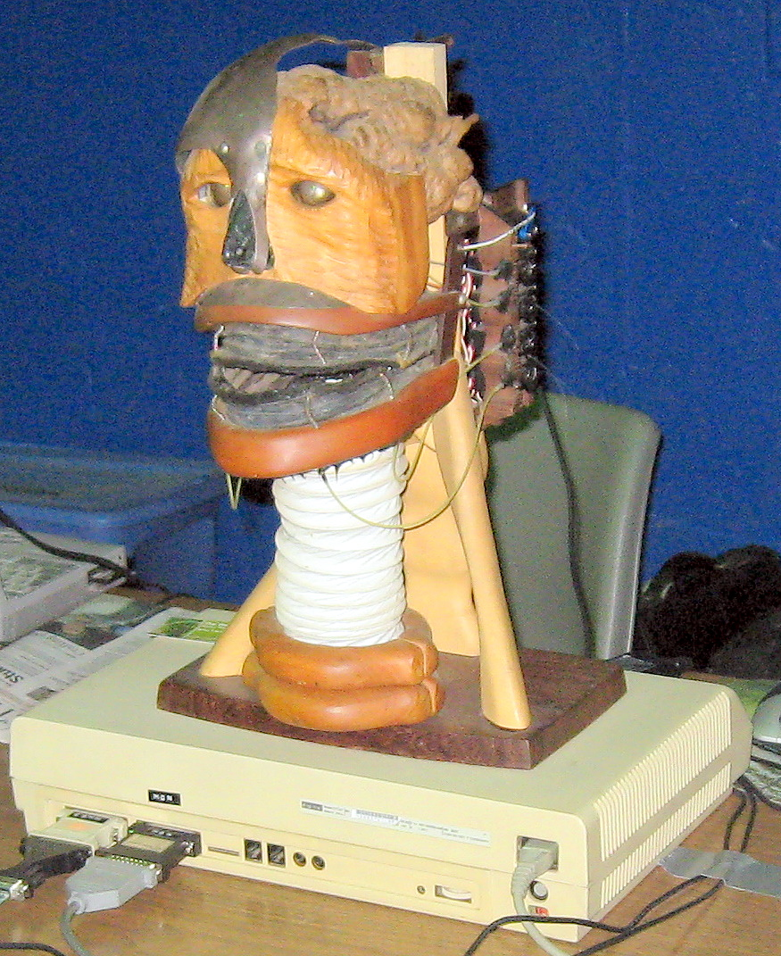
“The Babbling Head”
By Brooks Coleman, Alex Isles,
Bill Craig & Eric Lundquist

The babbling head is a kinetic sculpture made from both exotic & common woods such as Purple Heartwood, Pow Amavia Wood and Oak. The organic “brain” in this robot is a piece a Tanzania root. The base of the piece is Purple Heartwood and the neck and collar bones are Pow Amavia wood. The robot is also fitted with servos, LEDs and a computer driven vintage DECTALK speech generator.

The computer sends “written” words to the DECTALK. The DECTALK then converts these words into sounds. The words (as “spoken”) are then sent back to the computer where they are evaluated and converted to movement commands for the jaw & lips. This allows the head to re-create the motions that a “real” face/mouth would create when speaking words.

This sculpture has been featured in numerous magazine and newspaper articles as well as TV shows such as “The Insomniac with Dave Atel” on Comedy Central.

